NAME: S.PRATIBA
DATE:27.10.25 ROLL NO.:241901080

EXERCISE 17
TO ANALYZE THE DIFFERENT TYPES OF SERVERS USING WEBLIZERS

AIM:
To analyse web server log files using Webalizer to generate detailed usage statistics and reports for Apache, Nginx, and other web servers, and to identify traffic patterns, visitor behaviour, and server performance.

ALGORITHM:
- Install Webalizer: Install the tool using package manager (apt/yum) on Linux/Unix system.
- Locate Log Files: Identify web server log files (Apache at /var/log/httpd/access_log, Nginx at /var/log/nginx/access.log).
- Configure Webalizer: Edit configuration file (/etc/webalizer.conf) to specify log file location, output directory, and hostname.
- Create Output Directory: Create directory where HTML reports will be saved (e.g., /var/www/usage).
- Run Webalizer: Execute command webalizer or webalizer -c configfile to process logs.
- Parse and Extract Data: Tool reads log entries, extracts IP addresses, pages accessed, referrers, browsers, timestamps.
- Generate Reports: Creates HTML pages and graphs showing monthly, daily, hourly statistics with tables and charts.
- View Results: Access generated HTML reports in browser to view traffic statistics and analyses.

OUTPUT:
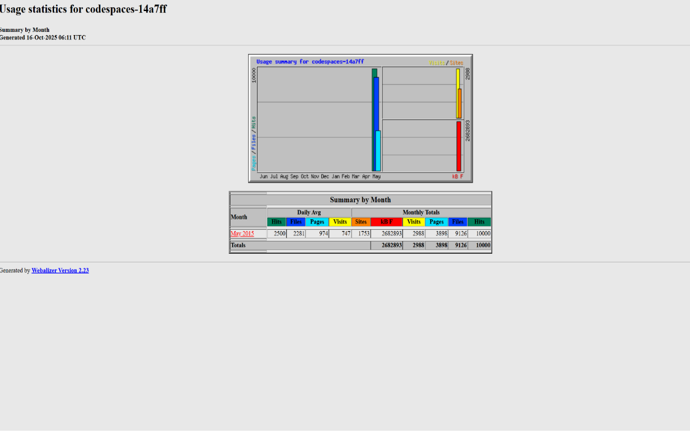
1. MONTHLY SUMMARY
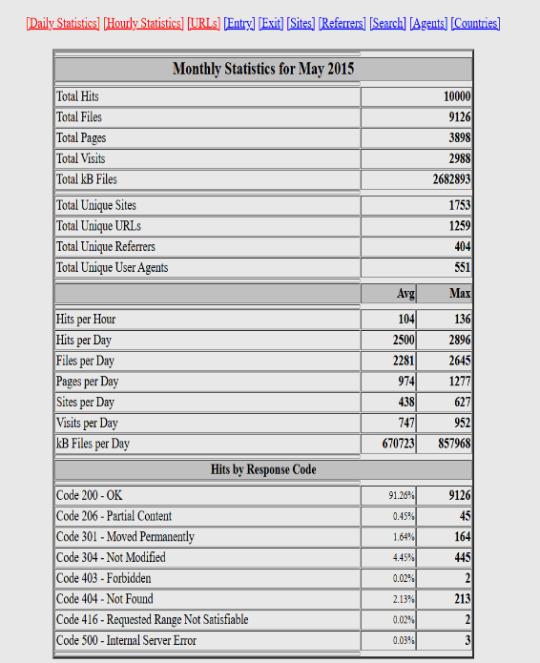

2. DAILY AND HOURLY GRAPHS:
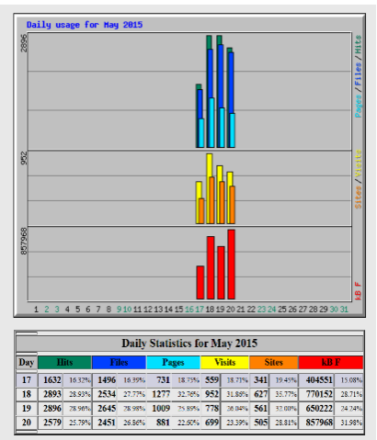
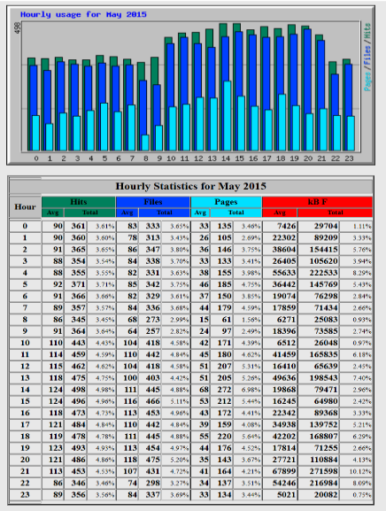
3. TOP URLS
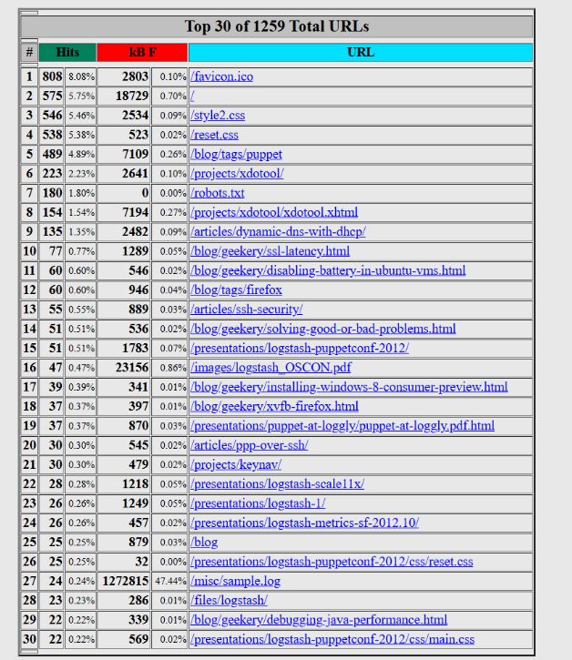

4. ENTRY AND EXIT PAGES
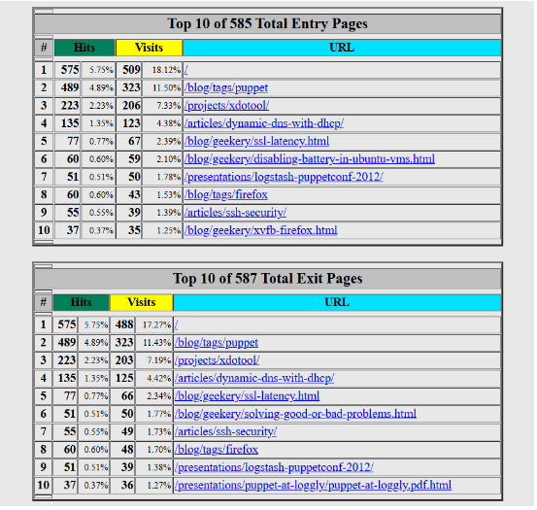
5. TOP SITES
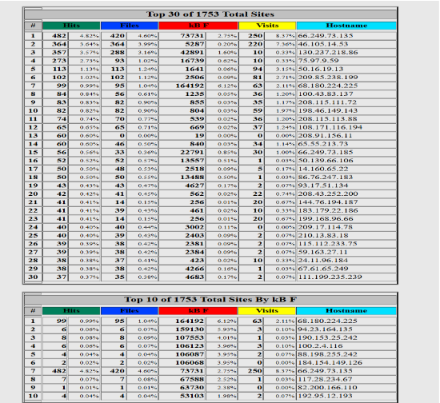

6. TOP REFERENCES
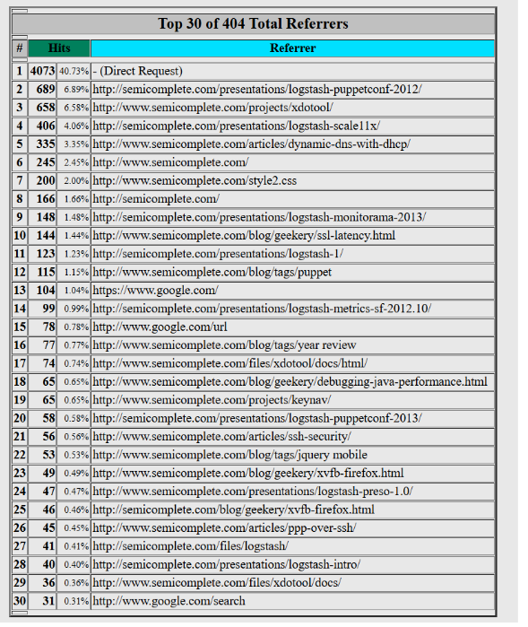
7. AGENTS
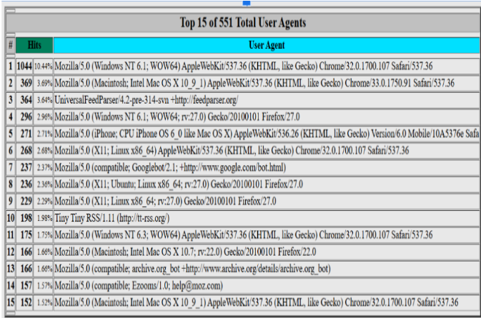

8. COUNTRIES AND DOMAINS
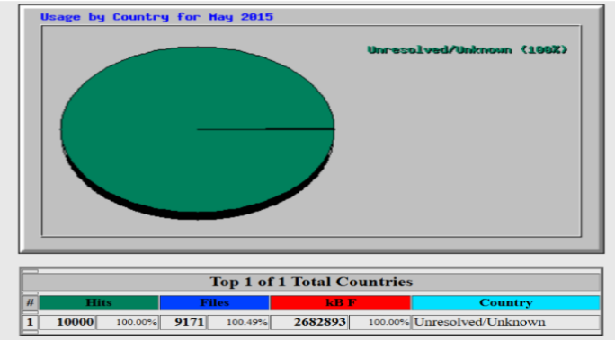

RESULT:
Webalizer successfully analyses web server logs from Apache, Nginx, ProFTPD, and Squid servers, generating detailed HTML reports showing visitor traffic patterns and server usage. The tool processes large log files quickly (up to 70,000 records per second) and provides actionable insights for server optimisation and traffic understanding.
- owing visitor traffic patterns and server usage. The

